Reminder:
Please use the Client Request link from our website, www.nwcompliance.org, when submitting ticket requests. This link takes you to our Workfront portal, but we may also include information on an interstitial page that could impact the response timing of your request, or other news regarding NWCG. If our website is down, you can go directly to https://nwcompliance.attask-ondemand.com/login to submit your request.
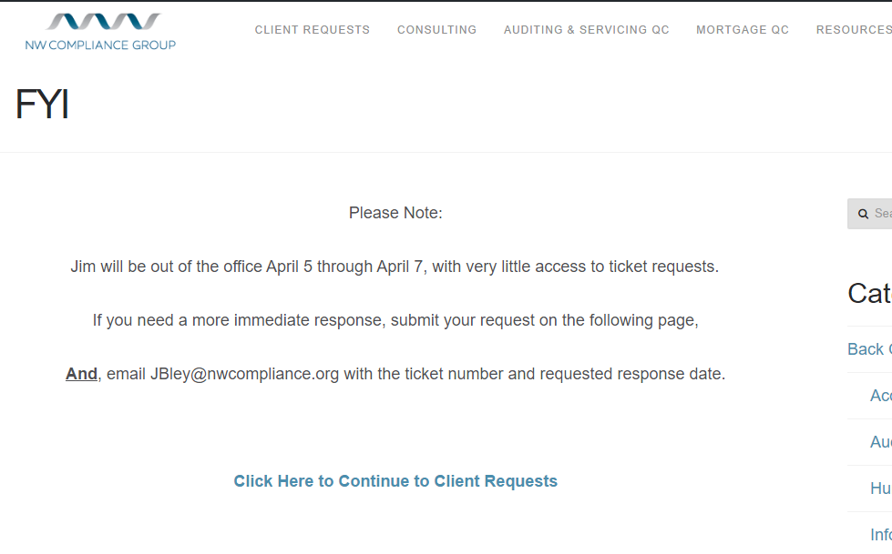

FINAL REGULATIONS/RULES
Effective Date | Regulation | Citation | Summary

PROPOSED REGULATIONS
Comments Due | Regulation | Citation | Summary
TBD | Regulation B (ECOA) | TBD | Aligns Regulation B with the new requirements for Regulation C and HMDA reporting.
04/05/2017 | Regulation E & Z – Prepaid Rule | 82 FR 13782 | The CFPB has proposed delaying the effective date of its final rule on covered prepaid accounts. The delay would move the effective date from October 1, 2017 to April 1, 2018, to allow industry to comply with the requirements.
RESOURCES/GUIDANCE
Guidance | Summary
.creditunion | Beginning this summer, credit unions can register and use a .creditunion domain name. The domain will be available to all U.S. credit unions through approved ICANN accredited registrars. Credit unions with qualified trademark rights will be able to register their domains beginning in May, and all others will be able to register starting in June.
NASCUC Executive Forum | May 23, 2017 in SeaTac, WA.
NASCUS Cybersecurity Symposium | June 5-6, 2017 in San Diego, CA.
WA DCU Bulletin B-17-06 | The DCU and the NCUA will work together, to cut down on duplicate requests, when obtaining a copy of the credit union’s audit report directly from the auditor.
WA DCU Bulletin B-17-07 | To strike a balance between the CALL Report Instructions and the AGO (i.e., accounting for repossessions at the time of repossession versus after a redemption period), the Washington State Attorney General’s Office recommend that within 30 days after repossession, the auto loan balance should be recorded in accordance with Generally Accepted Accounting Procedures (GAAP) and the CALL Report Instructions.
Credit Risk Trends | The FDIC’s Winter 2016 Supervisory Insights includes an article titled Credit Risk Trends and Supervisory Expectation Highlights, that identifies credit risk trends in commercial real estate along with agriculture, and oil and gas-related lending. The article contains good information regarding the conditions and trends in each of these areas, and is a recommended read for the policy makers in your institution.
Prepaid Rule – Short Form Disclosure Guide | On January 31, the CFPB released a guide for preparing the short form disclosure for prepaid accounts. The guide is based on Regulation E’s Model Form A-10(c) and provides basic “how to” instructions to help financial institutions prepare short form disclosures for prepaid accounts. The CFPB also has a page dedicated to the Prepaid Rule that includes a small entity guide, coverage chart, and other useful information for the credit union. Most of the requirements of the Prepaid rule are effective date October 1, 2017 (April 1, 2018)

Oregon
HB 2581 | Would require a person that possesses or has access to account information to report breach of security to the financial institution that issued financial access device. Person includes: an individual, a private or public corporation, partnership, cooperative, association, estate, limited liability company, organization or other entity. | First reading
HB 2161 | Included in the Bill are a provision allowing the expulsion of a member that creates undue risk of loss, the elimination of the requirement that the credit union’s board of directors meets 10 times a year, and changes the date for exercise by state credit unions of powers available to federal credit unions without director approval to January 1, 2017, from January 1, 2013. | Passed House, referred to President’s desk
HB 2359 | Removes requirement for beneficiary in trust deed to send, and Attorney General to receive, copy of notice that beneficiary has denied grantor's eligibility for foreclosure avoidance measure. | Third reading
HB 2624 | Exempts out-of-state banks, extranational institutions and foreign associations from requirement to file notice before dealing in notes secured by mortgages or trust deeds, if authorized to conduct banking business in this state by certificate of Department of Consumer and Business Services. | Second reading
HB 2622 | Authorizes financial institution to refuse certain financial transactions when financial institution reasonably believes financial exploitation of vulnerable person may have occurred, may have been attempted or is being attempted. | Work session scheduled
HB 2229 | Requires school districts to offer instruction in financial literacy. | Work session scheduled
HB 2346 | Directs insured institution or credit union to accept declaration rather than affidavit from Department of Human Services or Oregon Health Authority to pay claim on death of depositor. | Public hearing scheduled
SB 113 | Provides that person identified in gift card as providing goods or services shall transfer to Department of State Lands remaining balance of gift card that cardholder has not used within five years after date of last transaction that used gift card for purchase. | First reading
SB 254 | Requires financial institutions to participate in data match system established by Department of Revenue to identify assets held at financial institutions by delinquent debtors. | First reading
Washington
HB 1209  SB 5396 | Allow credit unions to accept public deposits that exceed the maximum deposit insured by the NCUA share insurance fund. | SHB Passed House  In Senate Committee
HB 1318 | Allow state-chartered credit unions to accept supplemental capital to build net worth. | In House Committee

IMPORTANT DATES
Call Report due dates for 2017: January 29, April 30, July 30, and October 29 (the last Sunday of the month following the quarter end).

