Reminder:
Please use the Client Request link from our website, www.nwcompliance.org, when submitting ticket requests. This link takes you to our Workfront portal, but we may also include information on an interstitial page that could impact the response timing of your request, or other news regarding NWCG. If our website is down, you can go directly to https://nwcompliance.attask-ondemand.com/login to submit your request.
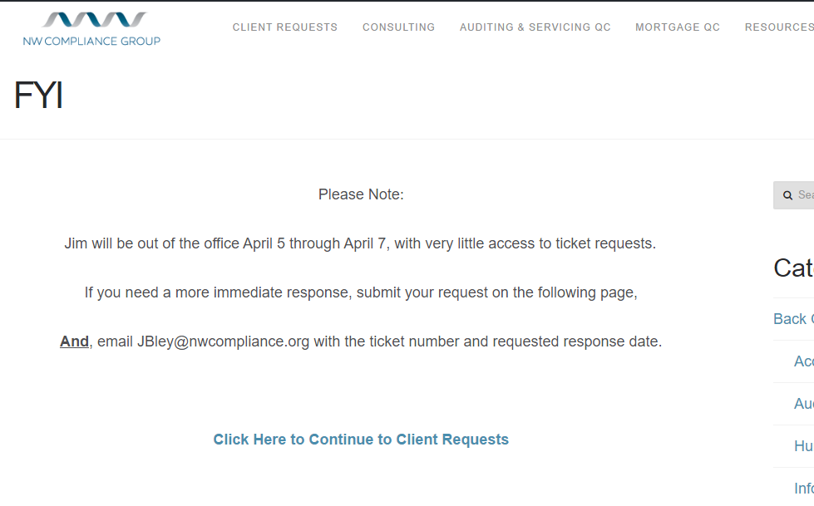

FINAL REGULATIONS/RULES
Effective Date | Regulation | Citation | Summary

PROPOSED REGULATIONS
Comments Due | Regulation | Citation | Summary
04/03/2017 | SAR Filing | 82 FR 9109 | FinCEN has published a notice of proposed changes to the SAR form. The notice does not propose any new regulatory requirements or changes to the requirements related to suspicious activity reporting other than changes to the data fields provided in the SAR filings. Most of the proposed changes would alter the “checklist” of violations in Part II, including the addition of several fields related to cyber events.
05/09/2017 | Alternative Capital ANPR | 82 FR 9691 | The NCUA is issuing the advanced notice of proposed rulemaking to solicit comments on alternative forms of capital federally insured credit unions could use in meeting capital standards required by statute and regulation
With all the confusion around this rule I did not know whether to post it in the Final or Proposed stage summaries, so I am including it separately:
The previously approved Fiduciary Rule, which had an effective date of April 10, 2017, is back in the comment stage until March 17, 2017, with the final rule now effective June 9, 2017. The delay, and new comment stage, were a result of President Trump’s Memorandum that directs the DOL to rescind or revise the rule if the review determines that it is inconsistent with the Administration’s priorities regarding consumer access to retirement information and financial advice. The comment period on the Memorandum runs through April 17, 2017.
RESOURCES/GUIDANCE
Guidance | Summary
Top Frauds of 2016 | The FTC released its annual Consumer Sentinel Data Book, which discusses fraud complaints that they receive. I found it interesting that the majority of fraud payments are still being done by wire transfers, and the number one method of contact for fraud is the telephone.
Using Email Authentication to Deter Phishing | The FTC put out a Staff Perspective on methods businesses can use to deter email phishing scams. The Perspective discusses using Sender Policy Framework (SPF), DomainKeys Identified Mail (DKIM), and Domain Message Authentication Reporting & Conformance (DMARC).
ADA Website Accessibility Tools | The Department of Justice recently published an “ADA Best Practices Tool Kit,” which includes website accessibility guidance and a checklist that can be used to verify compliance with the Americans with Disabilities Act. The guidance identifies common website accessibility problems and proposes solutions and other considerations that are useful in developing ADA compliant websites. It also includes a detailed action plan for making existing web content accessible. The checklist is intended to guide preliminary assessments of website accessibility, and policies and procedures for maintaining website accessibility.
DCU Consumer Protection Compliance Exam Focus | The DCU released its enhanced compliance exam focus for the next three years. The focus includes: Compliance Management Systems, UDAAP, and other areas of consumer protection – ECOA, HMDA, RESPA, TILA, and SCRA.
Alternative Data – Request for Information | The CFPB released a Request for Information into ways to expand access to credit for consumers who are credit invisible or who lack enough credit history to obtain a credit score. The Bureau is seeking public feedback on the benefits and risks of tapping alternative data sources such as bills for mobile phones and rent payments to make lending decisions about consumers whose lack of credit history might otherwise block opportunities.
MLA Website Error | Between 2/09/17 and 2/15/17, there was a problem with the MLA Multiple Record Requests. Credit unions that ran multiple record requests during this time are recommended to re-run the files.
Consumer Review Fairness Act | The FTC issued the ‘Consumer Review Fairness Act: What Business Need to Know’ which describes the protections given to consumers when sharing their honest opinions of the company.
Compressed Version of SDN List | OFAC is now offering a compressed version of its SDN.XML file in order to provide bandwidth savings for users that frequently download this file. This new file compresses the SDN.XML file by approximately 92%.
FDIC’s Money Smart Alliance Program | The FDIC provides a Money Smart Alliance program, which is a network for financial institutions, nonprofits, and governmental organizations that can use the FDIC’s financial education curriculum to provide training to consumers, small businesses and others.
Contaminated Currency | The Federal Reserve updated its procedures for submitting deposits of contaminated currency. Effective immediately, FedCash customers and contracted agencies that prepare their deposits for shipment to the Federal Reserve must adhere to the revised procedures and use the updated form to notify the Fed before delivering contaminated currency.

Oregon
HB 2161 | Included in the Bill are a provision allowing the expulsion of a member that creates undue risk of loss, the elimination of the requirement that the credit union’s board of directors meets 10 times a year, and changes the date for exercise by state credit unions of powers available to federal credit unions without director approval to January 1, 2017, from January 1, 2013. | Referred to Speaker’s desk
HB 2359 | Removes requirement for beneficiary in trust deed to send, and Attorney General to receive, copy of notice that beneficiary has denied grantor's eligibility for foreclosure avoidance measure. | Third reading
HB 2624 | Exempts out-of-state banks, extranational institutions and foreign associations from requirement to file notice before dealing in notes secured by mortgages or trust deeds, if authorized to conduct banking business in this state by certificate of Department of Consumer and Business Services. | Second reading
HB 2622 | Authorizes financial institution to refuse certain financial transactions when financial institution reasonably believes financial exploitation of vulnerable person may have occurred, may have been attempted or is being attempted. | Work session scheduled
HB 2229 | Requires school districts to offer instruction in financial literacy. | Work session scheduled
HB 2346 | Directs insured institution or credit union to accept declaration rather than affidavit from Department of Human Services or Oregon Health Authority to pay claim on death of depositor. | Public hearing scheduled
SB 113 | Provides that person identified in gift card as providing goods or services shall transfer to Department of State Lands remaining balance of gift card that cardholder has not used within five years after date of last transaction that used gift card for purchase. | First reading
SB 254 | Requires financial institutions to participate in data match system established by Department of Revenue to identify assets held at financial institutions by delinquent debtors. | First reading
Washington
HB 1209  SB 5396 | Allow credit unions to accept public deposits that exceed the maximum deposit insured by the NCUA share insurance fund. | Passed House  In Senate Committee
HB 1318 | Allow state-chartered credit unions to accept supplemental capital to build net worth. | In House Committee

IMPORTANT DATES
Call Report due dates for 2017: January 29, April 30, July 30, and October 29 (the last Sunday of the month following the quarter end).

